INCHGARTH COMMUNITY CENTRE
Programme of activities

Visit our website www.inchgarth.org 01224 325191
Follow us on social media
www.facebook.com/inchgarthcc www.facebook.com/peggysatinchgarth
www.facebook.com/musicinchgarth www.twitter.com/inchgarthcc www.instagram.com/inchgarthcc

 | MONDAY
HOW TO BOOK | ACTIVITY | TIME
Call 01224 313323  Contact Ms society | Computer class for additional support needs  Ms Society arts and crafts | 10am-12pn  12.30-3pm
Call us to book | Indoor carpet bowls  NEW FREE YOGA CLASS | 10am-12 noon  10.30-11.30
Call MS 07985989605 | Meta-fit by Laura  Ms society fitness class | 10.15am-10.45am  10.30am-11.30am
Call us to book | Special needs art class | 10am-12pm
Drop in members only | Fitness gym | 10am-5pm
Call us to book | Sensory room for hire | 10am- 5pm
Drop in | Outdoor play park | 9am-10pm
Call us to book | Music room for use | 10am- 9pm
Call us to book | Ipad /laptop/ wifi access NEW IT SUITE | All day
Drop in | Tennis courts free to use | 10am- 5pm
Drop in. Must be member  Call us for more info. | Pool & snooker drop in  New community garden volunteer project | 10am- 6pm  10am-12 noon
Drop in | Peggy’s café | 10am-5pm
Call us to book | Garthdee pensioners club | 1pm-3pm
Call 07563002500 | NEW CHILDREN’S CAPOEIRA CLASS | 4pm-5pm
Drop in  CALL TO BOOK | Indoor carpet bowls  Tablet class. Free to members | 12:45-1:45  3.15-4.45pm
At Rgu Sir Ian Wood building. FREE to go.  Call 01224 325191 | NEW INCHGARTH/ RGU MOVIE CLUB.  With Rgu movie monthly (visit rgu movie monthly via facebook)  NEW stitch n Bitch knitting, sewing, needle work. | 5.30pm
Drop in members only | Fitness gym | 6pm-10pm
Drop in | Friskis and svettis fitness | 6pm-7pm
Drop in | St Mary’s boxing club | 7pm-9pm
Call Sally 01224781230 | Dog training (puppies) | 7pm-8pm
 | Dog training (not puppies) | 8pm-9pm
taking new members now | Phoenix club – special needs | 7pm – 9pm
Drop in | Denis law legacy trust streetsports | 4.30-5.30pm
Drop in | Councillor Townson surgery | 7pm-8pm
Drop in | Metafit with laura | 6-6:30pm
Drop in  Call origin yoga to book | Abs fitness with laura  NEW YOGA CLASS | 6:30-7pm  7PM

Inchgarth cc A QUEEN’S AWARD- MBE RECIPIENT
 | Tuesday
How to book | ACTIVITY | Time
Drop in | Peggy’s café | 10am-9pm
Drop in. Must be members | Pool & snooker drop in | 10am-9pm
Call create 01224313323 | Create-the big bang –music | 10.30am-12noon
Drop in members - call us | Fitness gym | 10am- 5pm
Drop in | Outdoor play park | 9am-10pm
Call Ms Society 07985989605  Call us to book 01224 325191. | Ms society fitness class  NEW community garden project. Get involved! | 10am-11am  11am onwards
Call create 01224313323 | Sensory room by create | 10am-3pm
Call to book | Music room for use | 10am-9pm
Drop in | Tennis court free to use | 10am-5pm
Call Future choices | Future choices social day | 11am-2pm
Call us to book | Art class various medium | 1:30-3:30pm
Call us on 01224 325191  Call create 01224313323 | NEW BOCCIA for adults with disabilities  Create media group | 1pm-3pm  1pm-3pm
Call us to book | Card making class | 2pm-4pm
Must be members. Drop in  CALL TO BOOK | Beginners computer class  Ipad /laptop/ wifi access NEW IT SUITE  NEW BAKING CLASS | 3-4pm  All day  3-5PM
Call Claire. 07910649502 | Illusion dance Fun non competitive class | 4:30pm-5.30pm
Call Claire. 07910649502 | Illusion dance Competitive class Acro, stretch, fast, slow | 5.30pm-8.30pm
Call Gemma. 07985266109 | Music therapy group for additional support needs | 6pm-7pm
call | Tourette’s Scotland meetings Monthly | 7.30-9.30pm
Facebook message them | BiPolar Aberdeen Art group | 6.30-8.30pm
Drop in members only | Fitness gym | 6pm-9pm
Drop in | BOXING | 6pm-9pm
Drop in. 2nd Tuesday of month | Garthdee community council | 7pm-9pm monthly
Private group | Kaim-court residents meeting | 7pm-9pm monthly
Private group | Self help art class | 7pm-9pm

KIDS BIRTHDAY PARTY PACKAGES AT INCHGARTH
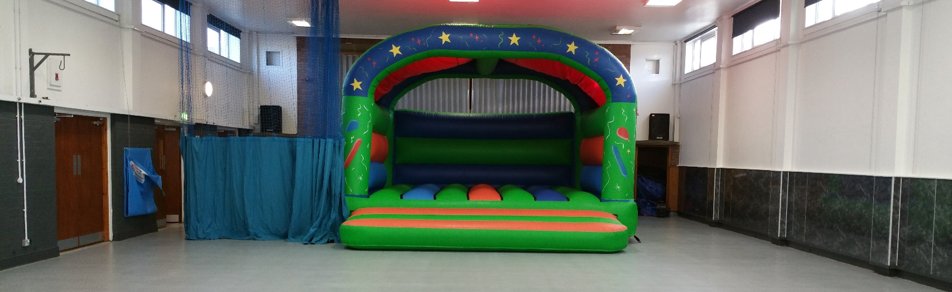
For just £90 you get this excellent hall and large castle.
Saturday 11am-1pm 2.15-4.15pm Sunday 10.15am-12.15pm 1pm-3pm 3.45pm-5.45pm
In order to enquire and book a party please call us on 01224 325191 to arrange an appointment

 | Wednesday
How to book | ACTIVITY | Time
Drop in | Peggy’s café | 10am-5pm
Drop in | Pool and snooker drop in | 10am-5pm
Call create 01224313323 | Create “oot & aboot” buddies club | 10am-12pm
Call us to book | Digital photography experienced | 10am-12pm
Drop in | Outdoor play park | 9am-10pm
Call create 01224313323 | Sensory room by create | 10am-5pm
Drop in | Ipad/ laptop/ wifi access  New Ms Yoga class | 10am-5pm  11am-12noon
Call Ms Society 07985989605 | Ms society art group | 12pm-3pm
Call Ms Society 07985989605 | Ms society social club | 12:30pm-3:30pm
Call us to book | Indoor carpet bowls | 9:30am-11:30am
Call us for induction | Fitness gym | 10am-5pm
Drop in | Tennis courts free to use | 10am-5pm
Call 0131 442 8840  Call Pathways to book | ABC language therapy down syndrome  PATHWAYS employment support | 10am-4:30pm  10am-12 noon
Call us to book | A chance to dance for the disabled | 1pm-3pm
Drop in | Food bank by TLC | 1pm- 4pm
Call us to book | Art class- various medium all levels | 2pm-4pm
Call us to book- must join as member | English language class- FREE | 7-8pm
Drop in | Friskis & svettis fitness | 6pm-7pm
Drop in | St Mary’s boxing club | 7pm-8 30pm
Call Laura on 07739181345  Drop in | Boxercise / Abs alternate weeks  Dennis law legacy trust street tennis | 6.15pm-7.15pm  6pm-7pm
Call 07532186155 | Brain injury Grampian social group | 7:30-10pm
Call Claire. 07910649502 | Illusion Dance Private lessons | 4pm-6.30pm
Call us for induction | Fitness gym | 6pm-10pm
Drop in | Councillor Yuill’s surgery | 7:15-8pm monthly
Call Paul on 01224694631 | Silver city ring craft show dogs | 7pm-9.30pm
Call 07703218382 | Granite city brass band | 7:30-10pm
Call to book | Music room to let | 10am-9pm
Drop in | Ipad and wifi access free | 7-10pm
Drop in | Inchgarth & streetsports football project At Ski centre pitches | 8:30pm-10pm
 | Baptist church | 6-8.15pm
P7 TO S4 | NEW SENIOR YOUTH CLUB | 7pm-9pm

Free tennis courts 7 days a week Inchgarth playpark 7 days a week
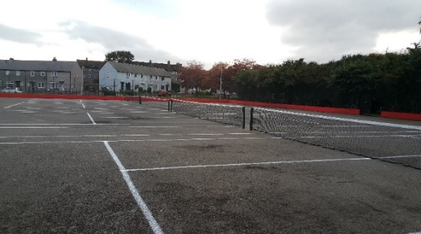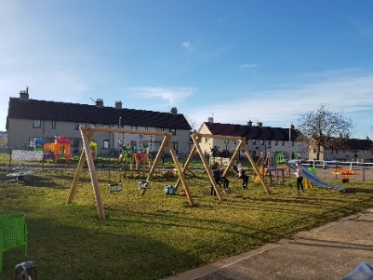

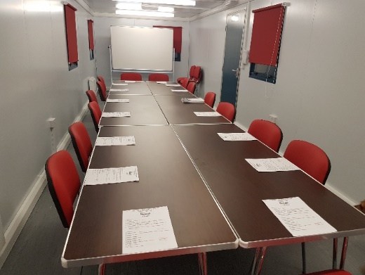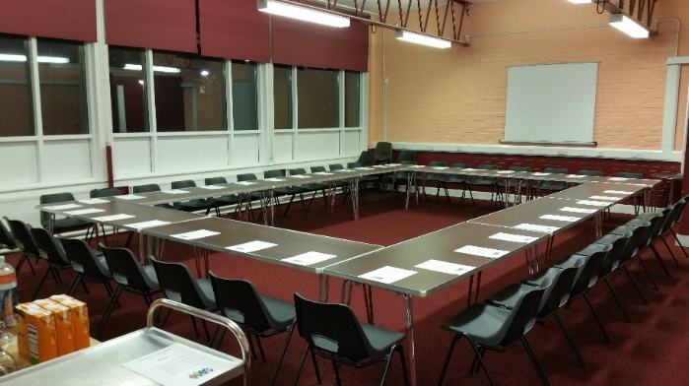

HIRE OUR EXCELLENT MEETING SPACES AND INVEST IN OUR VITAL WORK

2019 EVENTS… check the site for info

WWW.INCHGARTH.ORG

 | Thursday
How to book | ACTIVITY | Time
Drop in | Peggy’s café | 10am-5pm
Call create 01224313323 | Sensory room hire | 10am-3pm
Drop in and call for induction | Fitness gym | 10am-9:30pm
Ask for details.  Drop in | Foster parent group  Pool and snooker drop in | Monthly 11-1pm  10am-9.30pm
Call create 01224313323 | Create rock & pop experience
Drop in | Tennis courts free to use | 10am-5pm
Drop in | Out-door play park | 9am-10pm
Drop in | Bingo | 11am (be there 10:45)
Drop in | Parents and toddlers group free | 9:30am-11am
Drop in | The fish van | 10:30am-11am
Call to book | FREE Beginners computer class | 1-2pm
Drop in | Ipad/ laptop/ wifi access | All day
Call 01224632846 | Dog training under 6 months | 2pm-3pm
Call 01224632846 | Dog training over 6 months | 3pm-4pm
Call create 01224313323 | Create rock choir | 1pm-3pm
 | BiPolar Aberdeen support group | Last week of month 7pm-9.30pm
Call Claire. 07910649502 | Illusion dance Mini movers 18months +  Private lessons | 4pm-4.30pm  4.30pm onwards
Call | Puppy training class | 6pm-7pm
 | Meta-fit by Laura | 6.15pm-6.45pm
 | Dezibels samba drumming | 7:30pm-9:30pm
Call to book | Music room | 7pm-9pm
JUST TURN UP P3-S1 AGES | BEGINNERS CHEERLEADING | 7.05-8.05PM
 | MENS WELLBEING GROUP | 7-8.30PM
Drop in | Meditation class FREE | 7pm-8pm

 | Friday
How to book | ACTIVITY | Time
Drop in | Peggy’s café | 10am-5pm
Drop in | Metafit with Laura | 10am-10:30am
Drop in | Abs with Laura | 10:30am-11am
Call create 01224313323 | Create daycare services | 10am-12pm
Drop in | Pool and snooker drop in | 10am-5pm
Drop in members only | Fitness gym | 10am-5pm
Call to book | NEW CHAIR BASED gentle exercise | 10-11am
Drop in | Out door play park | 9am-10pm
Drop in | Tennis courts free to use | 10am-5pm
Drop in | Feel good Fridays- social club. | 1-3pm
Call us to book | Ipad/ laptop/ wifi access | 10am-6pm
Call us to book | Sensory room to hire | 10am-5pm
Call 07532186155 | Brain injury Grampian lunch club | 12pm-3pm
Call Gordon 07827445514 | Ultimate judo ages 4-7 | 3:45-4:30pm
Call Gordon 07827445514 | Ultimate judo ages 7-9 | 4:30pm-5:15pm
Call Gordon 07827445514  Call Claire. 07910649502  FOR MEMBERS ONLY  MUST REGISTER 01224325191 | Ultimate judo ages 10+  Illusion dance school Private lessons  Illusion dance school  Competitive class. Stretch, acro, fast, slow  NEW FRIDAY YOUTH CLUB | 5:15pm- 6pm  6pm-7pm  7pm-10pm  5pm-7pm call for all info

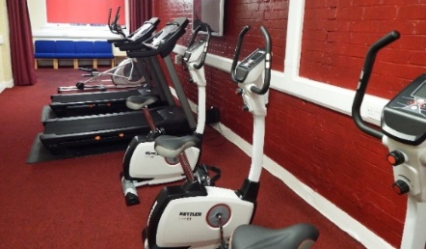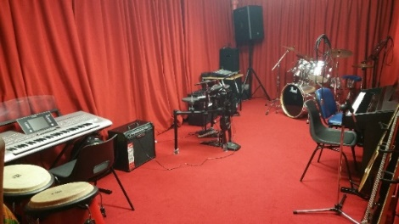
Call us to book an induction at our gym Hire our excellent music room- call for info

 | Sunday
How to book | ACTIVITY | Time
Call 01224733625 | Christadelphian church | 10am-1pm
Drop in members only | Fitness gym | 10am-10pm
Drop in | Tennis courts | 10am-5pm
Drop in | Out-door play park | 9am-10pm
Call to book  Drop in  Drop in | Music room to let  Pool and snooker drop in. Free for members  Baptist church | 1pm-10pm  10am-10pm  1.30-4.30pm
Call to arrange | Children’s birthday parties available to book | 10:15am – 12:15
Call to arrange | Children’s birthday parties available to book | 1pm – 3pm
Call to arrange | Children’s birthday parties available to book | 3:45-5:45pm
Call to arrange | Hall for lets for training, events, meetings | 1pm-6pm
Drop in | Peggy’s café (hot drinks & snacks only) | 10am-9pm
Call 01224733625 | Christadelphian church | 4pm-5:30pm
Call 07703218382 | Granite city brass band community band | 6pm-7.30pm
Call 07703218382 | Granite city brass band | 7.30pm-10pm
Drop in | Ipad and wifi access free | 10am to 10pm
Call us for details | German Shepard dog training | 6:30pm- 8:30pm
 | Saturday
How to book | Activity | Time
 | Children’s parties available to book | 11am-1pm
Drop in members only | Fitness gym | 9am-1:30pm
Call to book | Music room | 10am-2:15pm
Drop in | Peggy’s café (hot drinks and snacks only) | 9am- 1pm
Call to arrange | Children’s parties available to book | 2:15-4:15
Drop in | Tennis courts | 10am – 5pm
Call to arrange | Hall available for events | Varied
Call to book | Sensory room hire | 10am-2pm
Drop in | Outdoor play park | 9am-10pm
Drop in | Ipad and wifi access free | 9am to 1pm

Inchgarth relies on the goodwill of volunteers to run the centre, programme and the many services which we offer. We have many volunteering opportunities available that would make a lasting difference to the lives of others. Many take as little as 1 hour per week but have a huge impact on the lives of others.
Volunteering makes a huge difference to our community but also for the person kind enough to give up their time. Speak to a member of staff to learn more and see how you too could make that difference.

SOME 40 VOLUNTEERING ROLES AT INCHGARTH
Contact Jules our volunteer coordinator at volunteerinchgarth@gmail.com

INCHGARTH CC A QUEEN’S AWARD-MBE RECIPIENT

