ACTIVITIES FOR CHILDREN & YOUTHS
Inchgarth community centre Garthdee. www.inchgarth.org
Email inchgarthcc1@btinternet.com 01224 325191

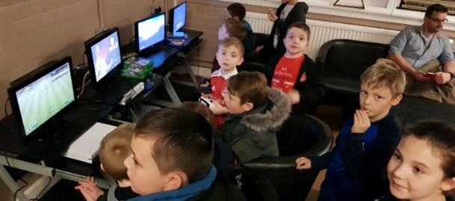
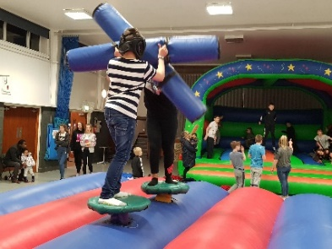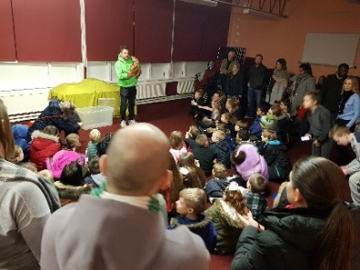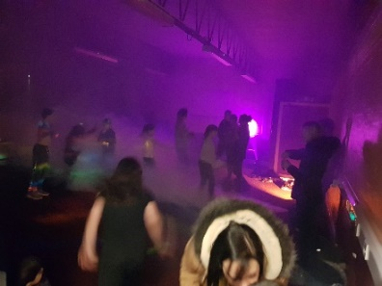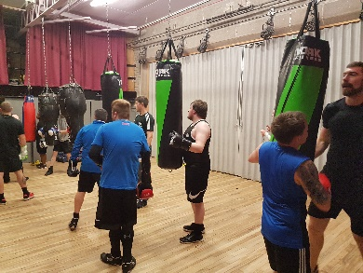
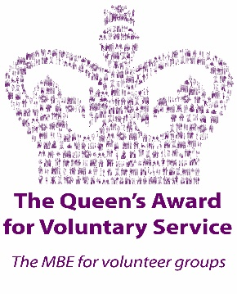

Dennis Law Rgu street sports. Monday 6-7pm Outdoors.
Primary aged children Free

St Mary’s Boxing club. Mon, Tues, Wed. 7pm Adults and children/ youths 8yrs +

Tennis courts. Free to access & open daily 7 days a week.

Outdoor playpark- 7 days a week, great facilities. FREE. 7yrs+

ILLUSION school of dance
Tuesday fun & fitness freestyle 4.30-5.30pm all ages and levels
Tuesday competitive classes 5.30-8.30pm
Thursday Mini movers 18 month+
Friday stretch, acro, fast, slow classes. 7-10pm

Ultimate Judo school
Fridays 3.45pm ages 4-6 4.30pm ages 7-9 5.15pm ages 10+

Kickabout pre-school football Wednesday 3.45-4.45pm

Dennis Law Rgu Street sports football at the Asda Astro-turf
Wednesday 8.30pm p7+ Free

Parent & Toddlers group. Thursday 9.30am-11am Free

Dezibels Samba Drummers Thursdays 7.30pm
Adult group but children p6+ can attend

Friday club. 5pm-7pm. FREE.
An amazing youth club for Garthdee children p3+
(younger can stay under their parental supervision)
Children can come from other areas too but the parents must stay and supervise.
In order for a child to attend parents must contact us before hand to register.

Youth volunteering- Saltire and Duke of Edinburgh
The centre hosts a significant amount of youth volunteers aged 13-25 who make a lasting and significant contribution to the community in addition to gaining valuable experience, life skills and new friends. Contact us for more details

DELIVERING OPPORTUNITIES FOR CHILDREN AND YOUTHS SINCE 1984
JUST UNDER 400 CHILDREN AND YOUTHS REGISTERED.
INCHGARTH….INVESTING IN YOUR CHILDREN’S FUTURE

