OPPORTUNITIES FOR ADULTS WITH ADDITIONAL SUPPORT NEEDS

Inchgarth community centre and our partners deliver a tremendous range of activities and facilities for people with learning & physical disabilities to enjoy. From art, dance, entertainment, music, rocks band, pool, bingo and so much more…there’s something for everyone.
You can keep up to date with all of our latest news, events and opportunities by visiting our website at www.inchgarth.org or following us on social media www.twitter.com/inchgarthcc www.facebook.com/inchgarthcc

A CENTRE OF EXCELLENCE LIKE NO OTHER
MONDAY ART CLUB 10AM-12 NOON
Every Monday Mandy Clubb our fantastic artist runs classes for people with disabilities. Carers enjoy a coffee in the corridor while participants do all of the projects themselves.
This class is free and funded by Inchgarth until March 2018 when a small fee will then be added. You must call us on 01224 325191 to check availability.
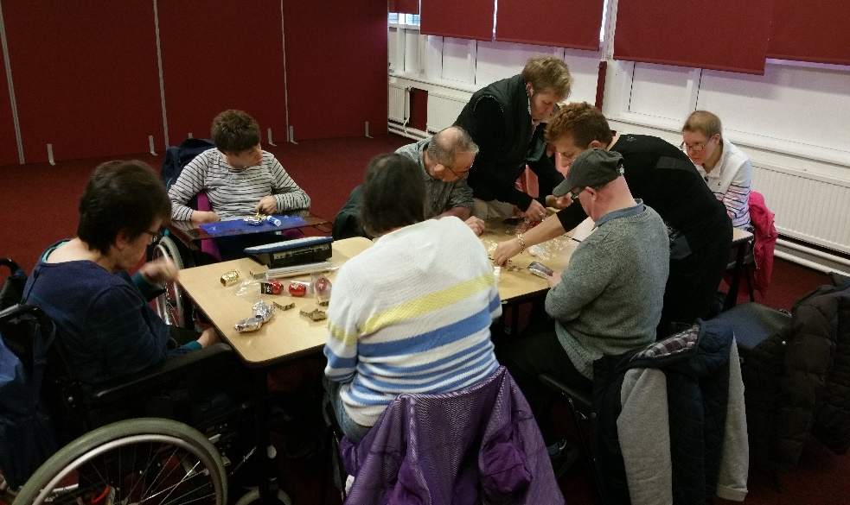

POOL AND SNOOKER DROP IN
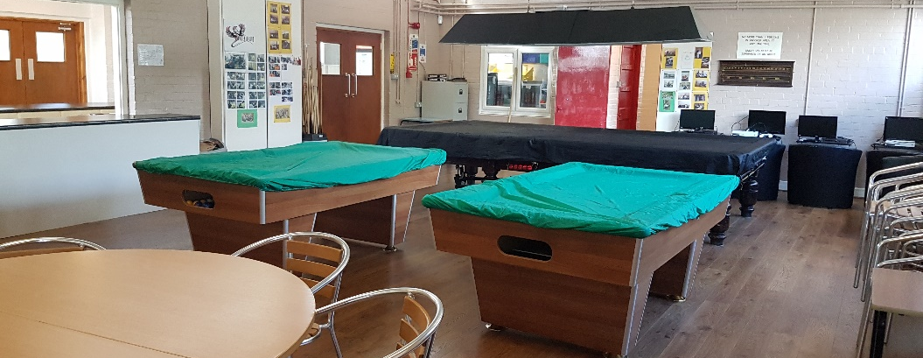
For just £5.00 per year, and no other costs, you can play pool Monday to Friday from 10am to 5pm.
What a bargain!!!!

SENSORY ROOM AT INCHGARTH
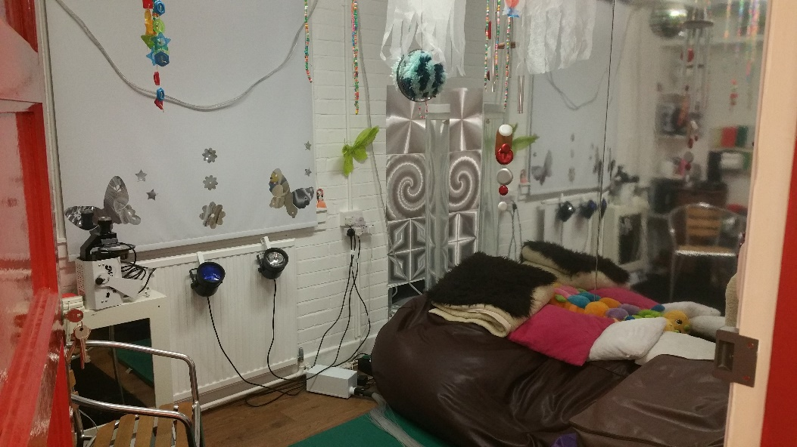
The sensory room at Inchgarth was created by Create Aberdeen who deliver one to one sessions every Wednesday.
Inchgarth hires out the space Mon, Tues, Thurs and Fri at £8.00 per hour. People must know how to use the space prior to booking as Inchgarth doesn’t give training on this.

For those who have no experience in using sensory rooms we advise that you organise a session with Create staff prior to booking a slot with Inchgarth in order to familiarise yourselves with the facility.
Contact create directly for a training session. Contact Inchgarth for hires only 325191

Inchgarth community centre is proud to have Create Aberdeen working in our centre delivering activities and services of excellence. In our view, no one does it better than Create. You can visit their site at www.createaberdeen.org
Tuesday | BIG BANG  Drumming group  CREATIVE TIMES  Media group | 10.15am-12.15pm  1pm-3pm
Wednesday | BUDDIES CLUB  Social club  A CHANCE TO DANCE  A tremendous dance and fun social club | 10am-12noon  1pm-3pm  no need to book
Thursday | ACCA-POP  Singing group  ROCK BAND  A tremendous rock group | 10am-12noon  1pm-3pm
Friday | EASY MOVES  Gentle exercise group  FEEL GOOD FRIDAY’S  Something different every week from entertainment, dance, music, drumming. | 10am-12noon  1pm-3pm  No need to book

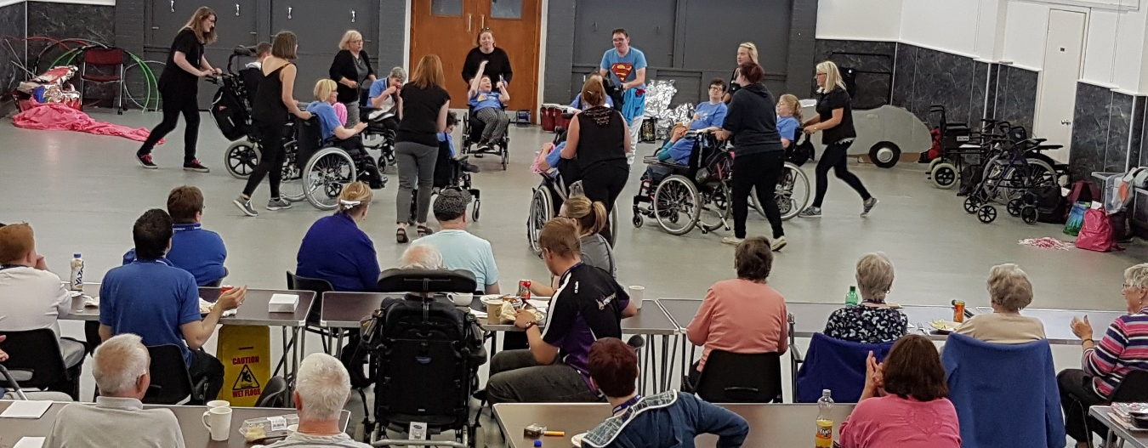

Welcome to Future Choices
“Future Choices was founded in November 2008, due to the day centre “Choices” (Westburn Road) being axed due to local council cuts. The centre provided social inclusion and recreational activities for the disabled community. It also provided respite for the carers. Rather than be left with nothing, a few disabled service users got together and formed the now voluntary run charity to replace a wide gap in the local community. The charity is completely self funded and is now over 9 years old, and still going strong even now.

Our group meets every Tuesday at Inchgarth community centre, 11am-2pm. For all enquiries on our charity and how to join contact me on 07821 700046.

My mother hugely benefitted from getting regular social inclusion, gaining herself independence, self esteem. To have that taken away from her was absolutely wrong. So along with the former Treasurer Gladys, we formed the charity to plug the gap and to continue to provide a vital service to the local community.”

David Forbes.
Chairman of Future Choices.

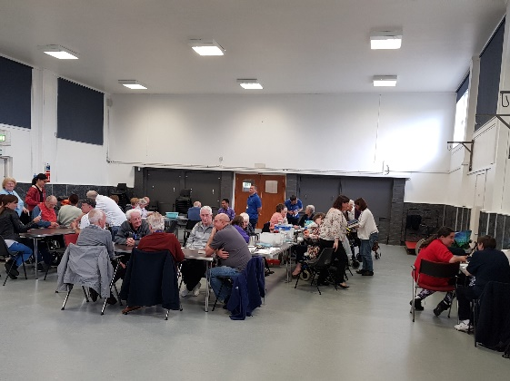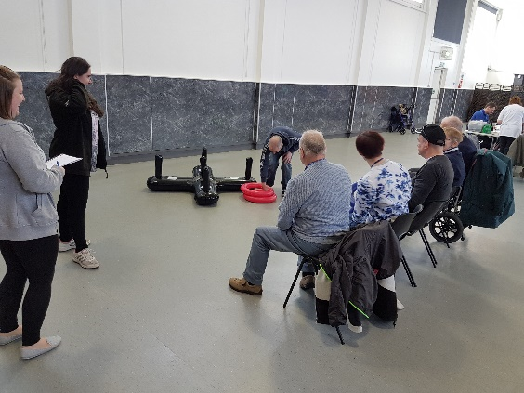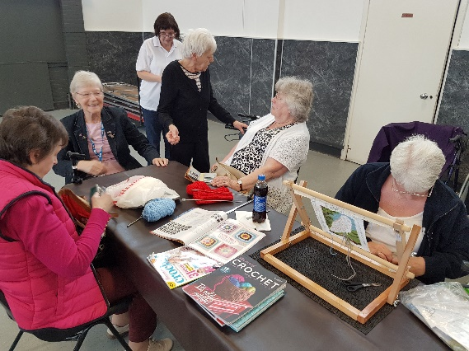
“ Future choices represents all that is good about volunteering, caring, and compassion in our city, while the friendship and opportunities the group fosters is a real lifeline for those who access the service. I cannot commend Future choices enough for the wonderful job they do, it’s a special place to be every Tuesday”

Paul O’ Connor MBE
Chairman and Manager of Inchgarth

THE PHOENIX CLUB
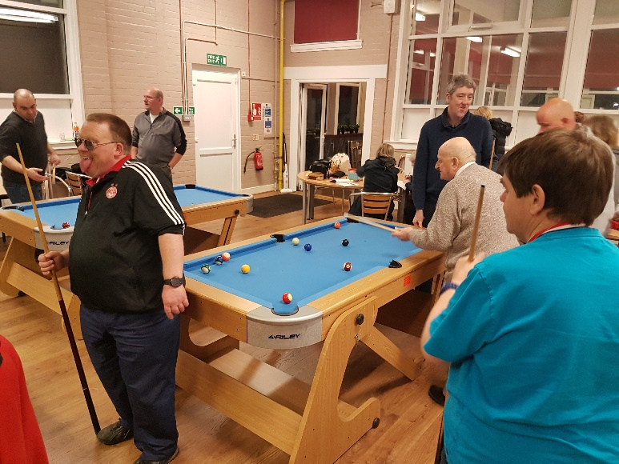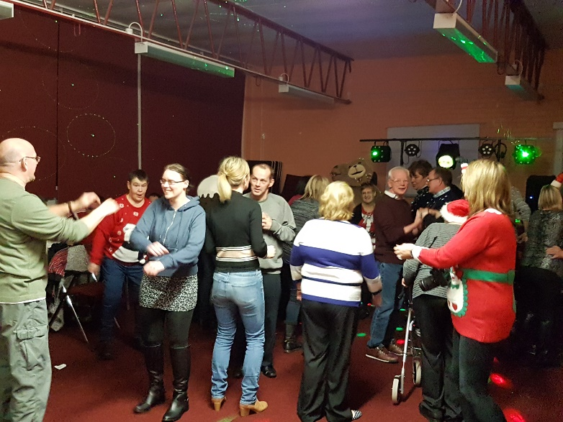
The Phoenix club is a wonderful social club run by Inchgarth community centre that takes place every Monday evening from 7pm-9pm. People can only join this club by calling us on 01224 325191 where we discuss an individual’s needs.
From entertainment, art, pool, karaoke, games, tuc-shop, trips and shows, it’s a wonderful social club for adults of all ages. People who have support needs must have their support worker in attendance.

FANCY VOLUNTEERING TO MAKE A REAL DIFFERENCE?
The phoenix club is looking for people to volunteer either as a minibus driver on a rota or for a club helper. Its fun, rewarding, and something that makes a real difference the lives of others.
Call us on 01224 325191 or speak to centre management at the centre.

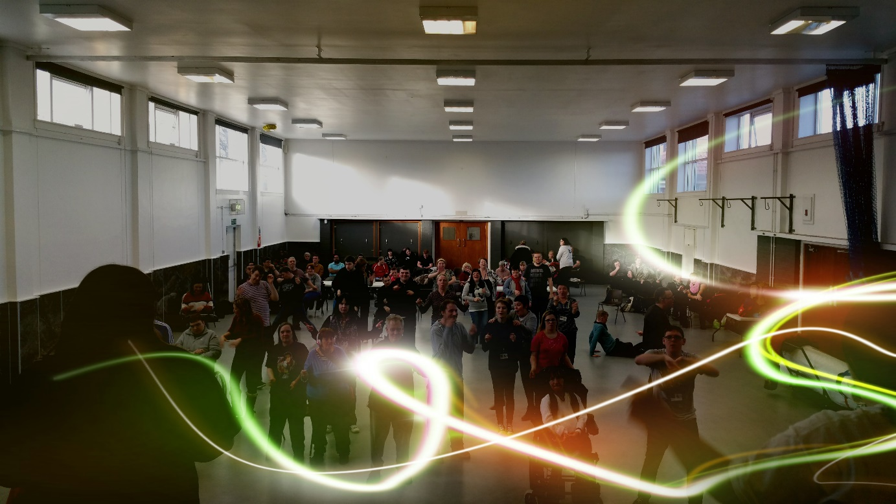
Every Wednesday from 1pm-3pm
A tremendously fun dance/ social group for adults with learning or physical disabilities run by Create Aberdeen on behalf of Inchgarth community centre. The class costs £4.00 per person paid on the day.

Why not have lunch before the class at our excellent Peggy’s café, or stay for a coffee/ juice after.

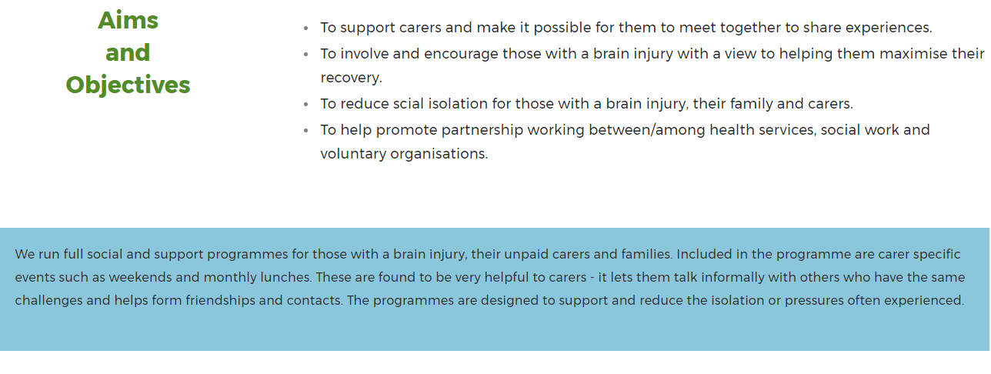
THE BIG GROUP MEETS AT INCHGARTH ONCE A MONTH ON A WEDNESDAY FOR A SOCIAL GROUP, TALKS AND MUCH MORE. 6.30PM ONCE A MONTH ON A FRIDAY IS THE EXCELLENT LUNCH AND SOCIAL CLUB 12NOON.
Visit their website for all enquiries www.brain-injury-grampian.weebly.com

The Aberdeen branch of the MS SOCIETY runs a series of excellent activities at Inchgarth which is now their base for local services. You can enquire more by contacting Ian Gourlay at ian.gourlay@btinternet.com

Monday Fitness class 10.30am-11.30am
Monday Arts and crafts 12.30pm-3pm
Tuesday Fitness class 10am-11am
Wednesday Yoga 11am-11.45am
Wednesday Arts and crafts 1pm-3pm
Wednesday Social group 1pm-3pm

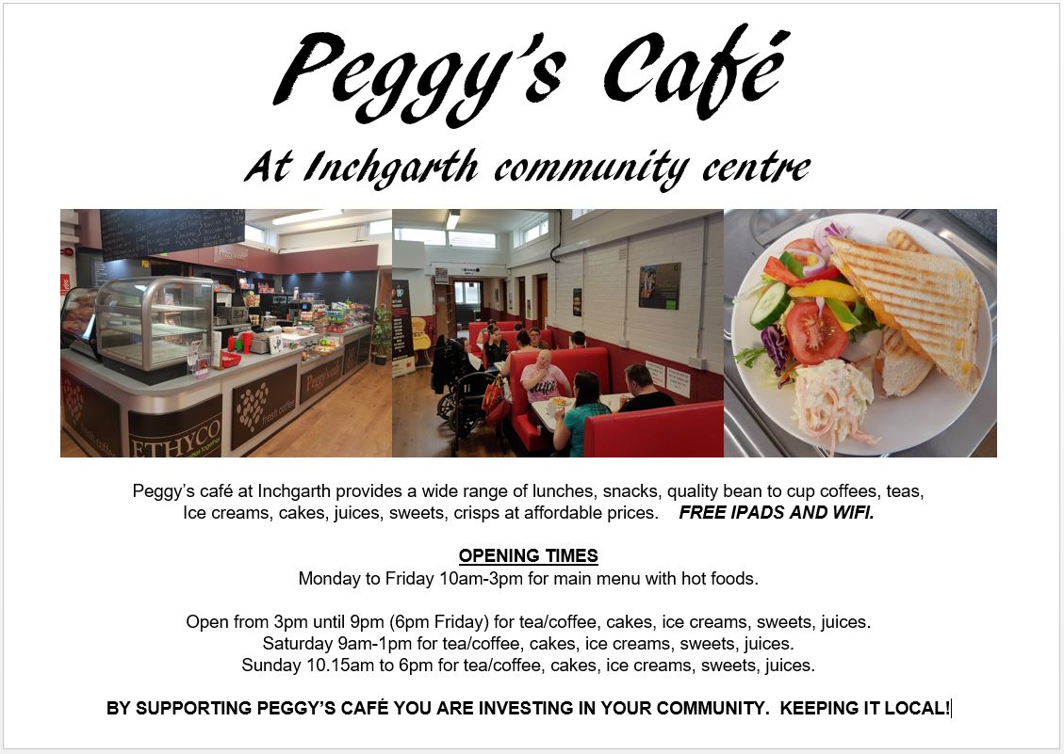

INCHGARTH MUSIC ROOM
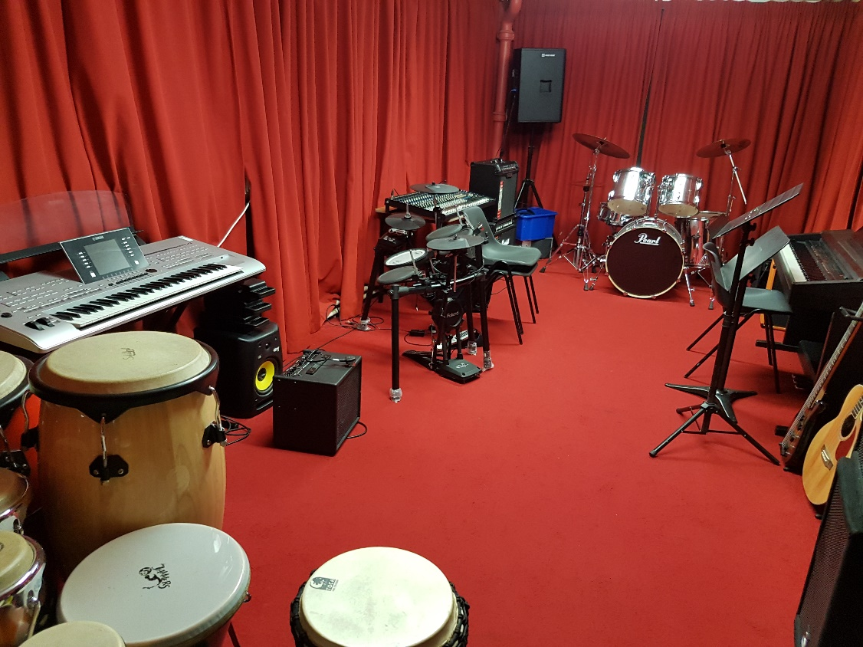

People can come along to Inchgarth’s music room, with their support worker, and so long as people are members of the centre, we will not impose any charge. What a bargain! Access to this space must be booked in advance by calling us on 01224 325191

OTHER OPPORTUNITIES.

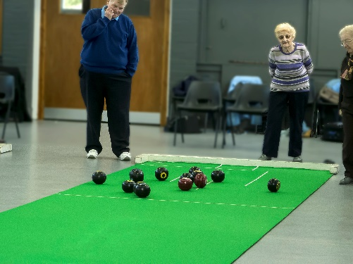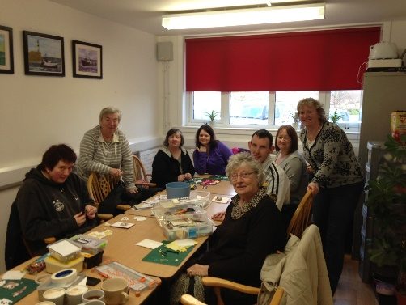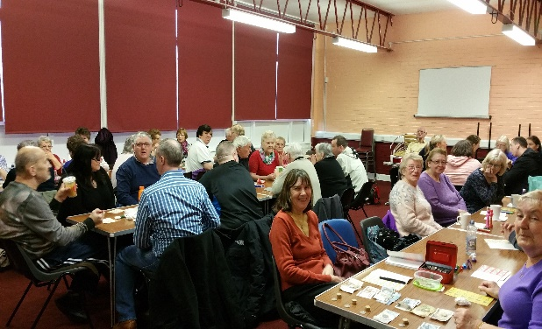

Inchgarth prides itself on the fact that a great deal of our classes in our general programme are designed and suitable for people with disabilities/ additional support needs to participate. This is over and above the dedicated services we offer for people with additional support needs.

Some ideas….

BINGO Thursday 11am-12 noon
CARD MAKING Tuesday 2pm-4pm
INDOOR BOWLS Monday 10am-12pm
Monday 12.45-1.45pm
INDOOR BOWLS Wednesday 9.30am-11.30am
TENNIS COURTS 7 days a week free all day
FITNESS GYM 7 days a week All day. Inductions must be arranged.

FULL CENTRE PROGRAMME
You can download the full programme at
www.inchgarth.org
150 sessions of activity for all ages!

