INCHGARTH COMMUNITY CENTRE
Programme of activities

Visit our website www.inchgarth.org 01224 325191
Follow us on social media
www.facebook.com/inchgarthcc www.facebook.com/peggysatinchgarth
www.facebook.com/musicinchgarth www.twitter.com/inchgarthcc
 | MONDAY
HOW TO BOOK | ACTIVITY | TIME
Contact Ms society | Ms Society arts and crafts | 12.30-3pm
Call us to book | Indoor carpet bowls | 10am-12 noon
Call MS 07985989605 | Ms society fitness class | 10.30am-11.30am
Call us to book | Special needs art class | 10am-12pm
Drop in members only | Fitness gym | 10am-5pm
Call us to book | Sensory room for hire | 10am- 5pm
Drop in | Outdoor play park | 9am-10pm
Call us to book | Music room for use | 10am- 9pm
Call us to book | Ipad /laptop/ wifi access | All day
Drop in | Tennis courts free to use | 10am- 5pm
Drop in. Must be member | Pool & snooker drop in | 10am- 5pm
Drop in | Peggy’s café | 10am-5pm
Call us to book | Garthdee pensioners club | 1pm-3pm
Call us to book | Beginners Tablet class | 12.15pm -2.15pm
Drop in  LIMITED SPACES | Indoor carpet bowls  NEW Primary aged gaming console club | 12:45-1:45  4pm-5pm
Call to book a place | Kids tennis coaching p1-p4 | 3:45-4:30pm
Call to book a place | Kids tennis coaching p5-s2 | 4:30- 5:15pm
Drop in members only | Fitness gym | 6pm-10pm
Drop in | Friskis and svettis fitness | 6pm-7pm
Drop in | St Mary’s boxing club | 7pm-9pm
Call Sally 01224781230 | Dog training (puppies) | 7pm-8pm
 | Dog training (not puppies) | 8pm-9pm
taking new members now call to discuss | Phoenix club – special needs | 7pm – 9pm
Drop in | Denis law legacy trust streetsports | 6pm-7pm
Drop in | Councillor Townson surgery | 7pm-8pm
Drop in | Metafit with laura | 6-6:30pm
Drop in  Just turn up | Abs fitness with laura  NEW YOGA CLASS | 6:30-7pm  7PM

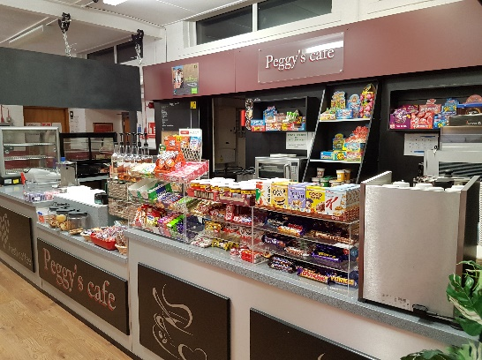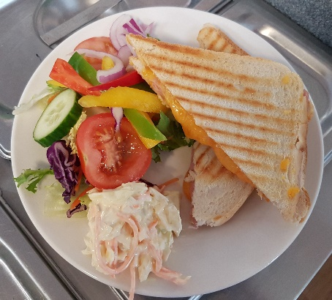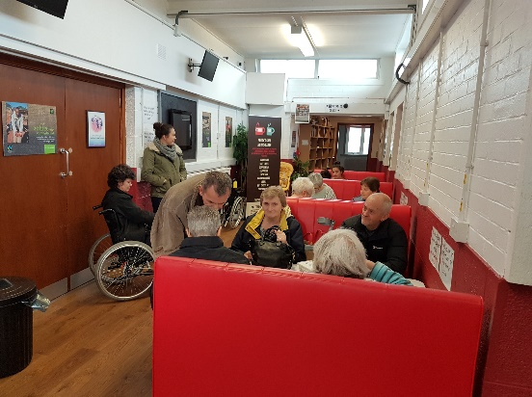
Peggy’s Café at Inchgarth. A tremendous investment in our community
 | Tuesday
How to book | ACTIVITY | Time
Drop in | Peggy’s café | 10am-9pm
Drop in. Must be members | Pool & snooker drop in | 10am-5pm
Call create 01224313323 | Create-the big bang –music | 10.30am-12noon
Call pathways | Pathways job seekers support | 10am-12noon
Drop in members - call us | Fitness gym | 10am- 5pm
Drop in | Outdoor play park | 9am-10pm
Call Ms Society 07985989605 | Ms society fitness class | 10am-11am
Call create 01224313323 | Sensory room by create | 10am-3pm
Call to book | Music room for use | 10am-9pm
Drop in | Tennis court free to use | 10am-5pm
Call Future choices | Future choices social day | 11am-2pm
Call us to book | Art class various medium | 1:30-3:30pm
Call create 01224313323 | Create media group | 1pm-3pm
Call us to book | Card making class | 2pm-4pm
Call us to book | Beginners computer class | 3:30pm-5:30pm
Call Claire. 07910649502 | Illusion dance non-competitive ages 4+ | 4:30pm-6:00pm
Call Claire. 07910649502 | Illusion Hip-Hop | 6:00pm-6.30pm
Call Claire. 07910649502 | Illusion Dance pairs- competitors | 6.30pm-7pm
Call Claire. 07910649502 | Illusion Dance competitors | 7pm-9pm
Call Gemma. 07985266109 | Music therapy group for additional support needs | 6pm-7pm
Drop in members only | Fitness gym | 6pm-9pm
Drop in | Women’s boxing sessions | 7pm-9pm
Drop in. 2nd Tuesday of month | Garthdee community council | 7pm-9pm monthly
Drop in | Ipad and wifi access free | 7pm-9pm
Private group | Kaim-court residents meeting | 7pm-9pm monthly
Private group | Horticultural group | 7-9pm monthly
Private group | Self help art class | 7pm-9pm

KIDS BIRTHDAY PARTY PACKAGES AT INCHGARTH
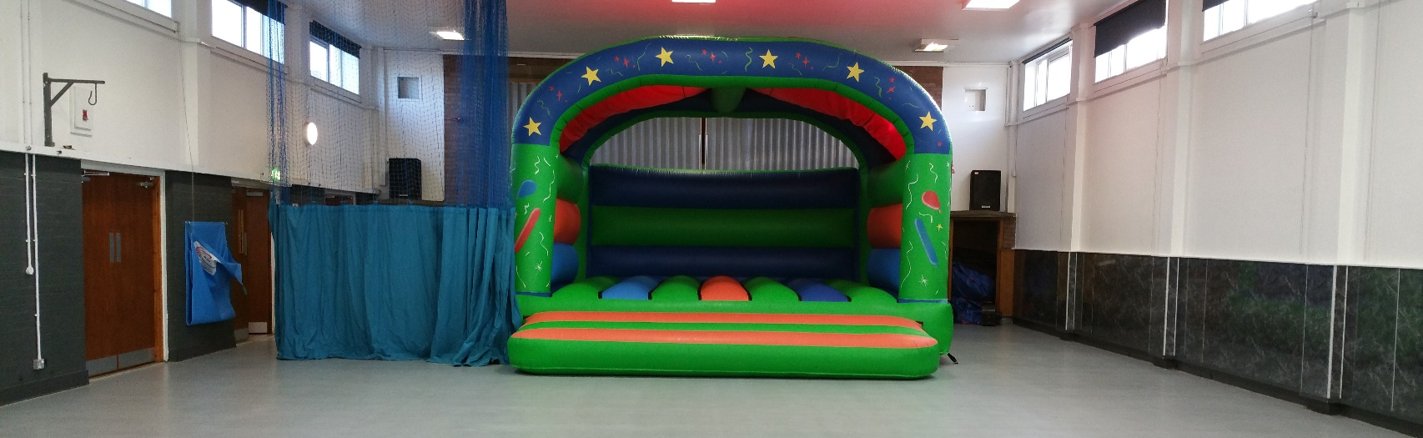
For just £90 you get this excellent hall and large castle.
Saturday 2.15-4.15pm Sunday 10.15am-12.15pm 1pm-3pm 3.45pm-5.45pm
In order to enquire and book a party please call us on 01224 325191 to arrange an appointment
 | Wednesday
How to book | ACTIVITY | Time
Drop in | Peggy’s café | 10am-5pm
Drop in | Pool and snooker drop in | 10am-5pm
Call create 01224313323 | Create “oot & aboot” buddies club | 10am-12pm
Call us to book | Digital photography experienced | 10am-12pm
Drop in | Outdoor play park | 9am-10pm
Call create 01224313323 | Sensory room by create | 10am-5pm
Drop in | Ipad/ laptop/ wifi access | 10am-5pm
Call Ms Society 07985989605 | Ms society art group | 12pm-3pm
Call Ms Society 07985989605 | Ms society social club | 12:30pm-3:30pm
Call us to book | Indoor carpet bowls | 9:30pm-11:30pm
Call us for induction | Fitness gym | 10am-5pm
Drop in | Tennis courts free to use | 10am-5pm
Call 0131 442 8840 | ABC language therapy down syndrome | 10am-4:30pm
Call us to book | A chance to dance for the disabled | 1pm-3pm
Drop in | Food bank by TLC | 1pm- 4pm
Call us to book | Art class- various medium all levels | 2pm-4pm
Call us to book  Facebook kickabout to enquire | Children’s art class  Pre school aged football 3-5 yrs | 4pm-5pm  3.45pm-4.45pm
Drop in | Friskis & svettis fitness | 6pm-7pm
Drop in | St Mary’s boxing club | 7pm-8 30pm
Call Laura on 07739181345  Drop in | Boxercise / Abs alternate weeks  Dennis law legacy trust street tennis | 6.15pm-7.15pm  7pm-8pm
Call 07532186155 | Brain injury Grampian social group | 7:30-10pm
Call Claire. 07910649502 | Illusion Dance Private lessons
Call us for induction | Fitness gym | 6pm-10pm
Drop in | Councillor Yuill’s surgery | 7:15-8pm monthly
Call Paul on 01224694631 | Silver city ring craft show dogs | 7pm-9.30pm
Call 07703218382 | Granite city brass band | 7:30-10pm
Call to book | Music room to let | 10am-9pm
Drop in | Ipad and wifi access free | 7-10pm
Drop in | Inchgarth & streetsports football project At Ski centre pitches | 8:30pm-10pm
Call for details | Aberdeen reading group | 7pm-9pm monthly 2nd wed month

Free tennis courts 7 days a week Inchgarth playpark 7 days a week
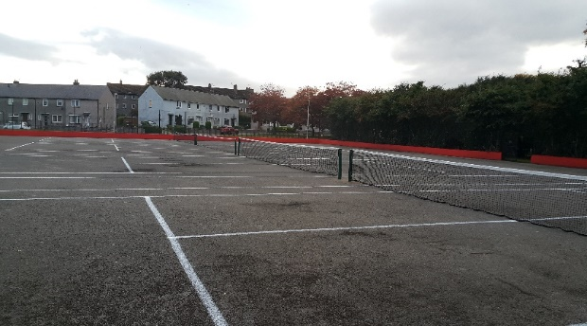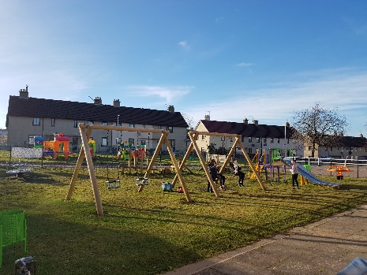

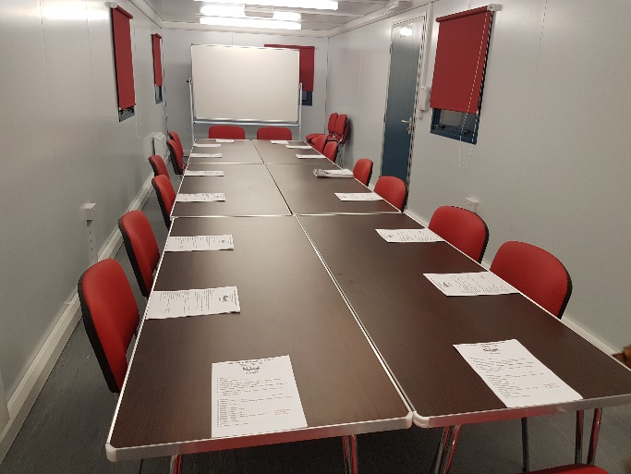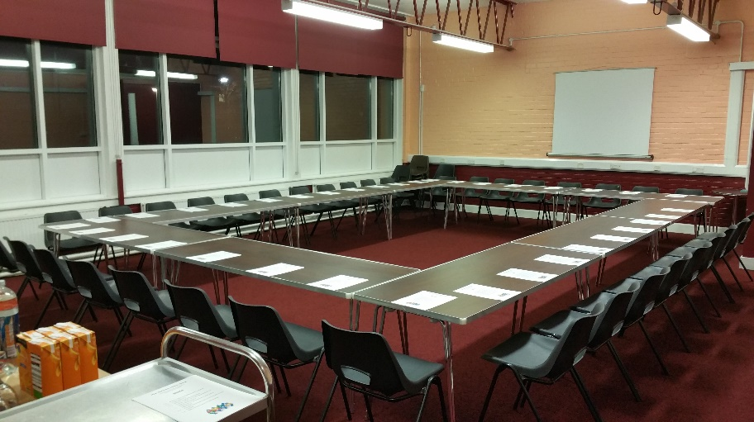

HIRE OUR EXCELLENT MEETING SPACES AND INVEST IN OUR VITAL WORK

2017 EVENTS

- Inchgarth Queens Award for Voluntary Service the MBE celebration night. Friday 29th Sept. Ticket only.
- Create Disco for additional support needs. 15th December 7pm
- Boogie Buddies xmas disco. 3rd December.
- Inchgarth big xmas party and community open day 17th December 12 noon to 3pm FREE
- Horse racing night- fundraiser for Inchgarth March 9th 2018
 | Thursday
How to book | ACTIVITY | Time
Drop in | Peggy’s café | 10am-5pm
Call create 01224313323 | Sensory room hire | 10am-3pm
Drop in and call for induction | Fitness gym | 10am-9:30pm
Drop in | Pool and snooker drop in | 10am-5pm
Call create 01224313323 | Create rock & pop experience
Drop in | Tennis courts free to use | 10am-5pm
Drop in | Out-door play park | 9am-10pm
Drop in | Bingo | 11am (be there 10:45)
Drop in | Parents and toddlers group free | 9:30am-11am
Drop in | The fish van | 10:30am-11am
Call us to book | Breast feeding social group | 9:30am-11:30am
Drop in | Ipad/ laptop/ wifi access | 10am-9pm
Call 01224632846 | Dog training under 6 months | 2pm-3pm
Call 01224632846 | Dog training over 6 months | 3pm-4pm
Call create 01224313323 | Create rock choir | 1pm-3pm
 | Alzheimer’s Scotland | 2pm-4pm
Private lessons | Illusion dance school
Alison Grimmer | ZUMBA by Alison | 6pm-7pm
 | Dezibels samba drumming | 7:30pm-9:30pm
Call to book | Music room | 7pm-9pm
 | k-9 dog training | 7pm-8pm
 | Dog training | 8pm-9pm
Drop in | Meditation class FREE | 7pm-8pm

 | Friday
How to book | ACTIVITY | Time
Drop in | Peggy’s café | 10am-5pm
Drop in | Metafit with Laura | 10am-10:30am
Drop in | Abs with Laura | 10:30am-11am
Call create 01224313323 | Create daycare services | 10am-12pm
Drop in | Pool and snooker drop in | 10am-5pm
Drop in members only | Fitness gym | 10am-5pm
Drop in | Out door play park | 9am-10pm
Drop in | Tennis courts free to use | 10am-5pm
Drop in | Feel good Friday’s- social club | 1-3pm
Call us to book | Ipad/ laptop/ wifi access | 10am-6pm
Call us to book | Sensory room to hire | 10am-5pm
Call 07532186155 | Brain injury Grampian lunch club | 12pm-3pm
Call Gordon 07827445514 | Ultimate judo ages 4-7 | 3:45-4:30pm
Call Gordon 07827445514 | Ultimate judo ages 7-9 | 4:30pm-5:15pm
Call Gordon 07827445514 | Ultimate judo ages 10+ | 5:15pm- 6pm
 | Saturday
How to book | Activity | Time
Call Claire. 07910649502 | Illusion dance ages 3 and under | 9am-9.30am
Call Claire. 07910649502 | Illusion dance Stretch and Acro | 9.30am-10.45am
Call Claire. 07910649502 | Illusion dance Slow dance competitors | 10.45am-12
Call Claire. 07910649502 | Dance school. Freestyle competitors | 12.30pm-1.30pm
Drop in members only | Fitness gym | 9am-1:30pm
Call to book | Music room | 10am-2:15pm
Drop in | Peggy’s café (hot drinks and snacks only) | 9am- 1pm
Call to arrange | Children’s party | 2:15-4:15
Drop in | Tennis courts | 10am – 5pm
Call to arrange | Hall available for events | Varied
Call to book | Sensory room hire | 10am-2pm
 | Fun factory kids club monthly | 1pm-3pm
Drop in | Outdoor play park | 9am-10pm
Drop in | Ipad and wifi access free | 9am to 1pm

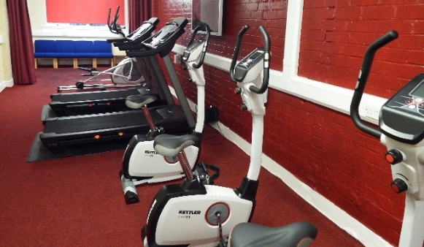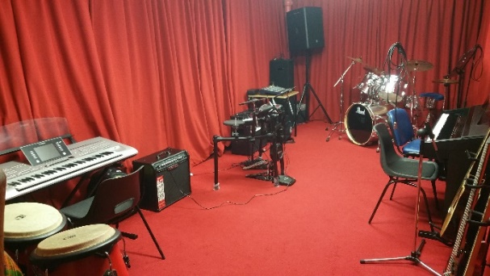
Call us to book an induction at our gym Hire our excellent music room- call for info

 | Sunday
How to book | ACTIVITY | Time
Call 01224733625 | Christadelphian church | 10am-1pm
Drop in members only | Fitness gym | 10am-10pm
Drop in | Tennis courts | 10am-5pm
Drop in | Out-door play park | 9am-10pm
Call to book | Music room to let | 1pm-10pm
Call to arrange | Children’s birthday parties | 10:15am – 12:15
Call to arrange | Children’s birthday parties | 1pm – 3pm
Call to arrange | Children’s birthday parties | 3:45-5:45pm
Call to arrange | Hall for lets for training, events, meetings | 1pm-6pm
Drop in | Peggy’s café (hot drinks & snacks only) | 10am-9pm
Call 01224733625 | Christadelphian church | 4pm-5:30pm
Call 07703218382 | Granite city brass band community band | 6pm-7.30pm
Call 07703218382 | Granite city brass band | 7.30pm-10pm
Drop in | Ipad and wifi access free | 10am to 10pm
Call us for details | German Shepard dog training | 6:30pm- 8:30pm

Inchgarth relies on the goodwill of volunteers to run the centre, programme and the many services which we offer.
We have many volunteering opportunities available that would make a lasting difference to the lives of others. Many take as little as 1 hour per week but have a huge impact on the lives of others.

Volunteering makes a huge difference to our community but also for the person kind enough to give up their time. Speak to a member of staff to learn more and see how you too could make that difference.

Peggy’s café worker, future choices social club helper, Phoenix club social club helper
Handy person, something to tidy gym and playpark, someone to sweep tennis courts,
Foodbank supporter, marketing worker, preschool organiser, befriender, music tutor, sports coaching
Painter, website designer, pensioners club helper, Ms society club befriender,
Brain injury social club helper, cleaner, maintenance helper, general organiser and so much more…..

